
PACK 232 – SNOW TUBING AT WEST MOUNTAIN



WHAT: Cub scout outing – snow tubing
WHEN: Saturday, January 30, 2010 - 2:30 – 4:30
WHERE: West Mountain, Queensbury, NY
COST: $14 per person (adult or child) To get the group rate, you have to arrive by 2:30, otherwise rate is $16 per person. No advance ticket purchase.

Scouts and families of Pack 232,
Join fellow scouts for an afternoon of winter fun! We will meet in the cafeteria of the ski lodge. Please arrive by 2:30 so we can all start together, but if you need to arrive late, you can still go tubing! Snacks are served in the cafeteria and there is a larger menu in the Westside Grill.

Snow tubing ticket is good for 2 hours. Wear ski or sledding clothes (snow boots, mittens, hat, ski mask or sun glasses if you have them, and dress in layers, etc). Siblings are welcome. It’s all the fun of sledding…without having to keep walking back up the hill!

Here’s a little video clip of some tubing at West Mountain:
http://www.youtube.com/watch?v=8ytw-sziDhU

West Mountain’s website: http://www.skiwestmountain.com/
DIRECTIONS: http://www.skiwestmountain.com/directions.cfm
Take the Northway (I-87) to Exit 18.
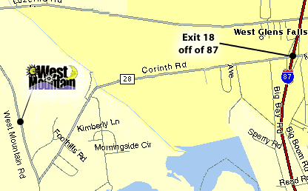

This event will be postponed if the weather is bad, and an email will be sent out if that’s the case.

RSVP: Please reply to this email if you are planning to attend and include how many will be going.

CAR POOLING: If you want to arrange a carpool with another family, please reply to this email or contact your den leader to reach other parents in your den.

